Example 1:

Text prompts: “a fish”, “a fin”



Example 2:

Text prompt: “an individual flower”



Example 3:

Text prompts: "a snake.", "a black square with colors in it."

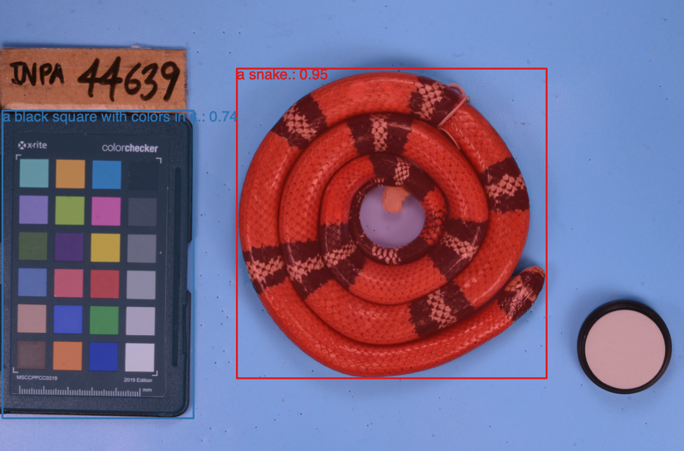

Example 4:

Text prompt: "a snake.", "a ruler."

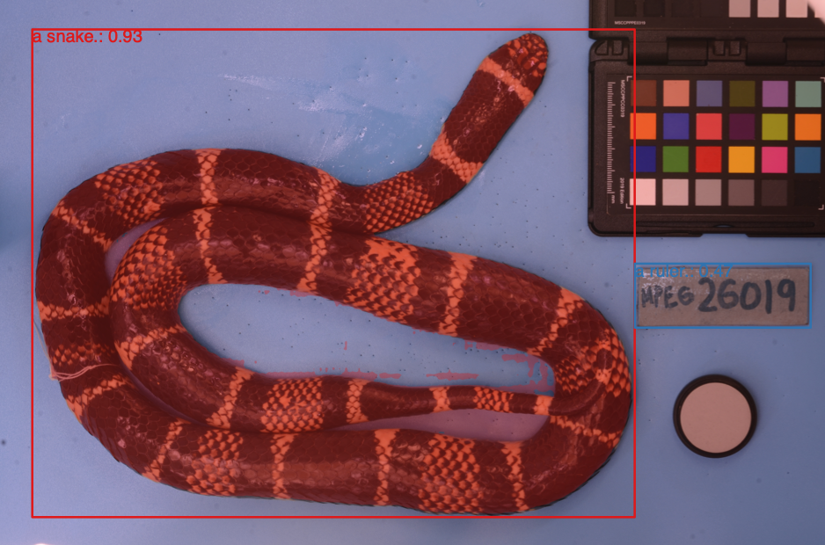

Example 5:

Text prompts: "a snake.", "small evenly spaced white dashes on a black background next to colorful squares."

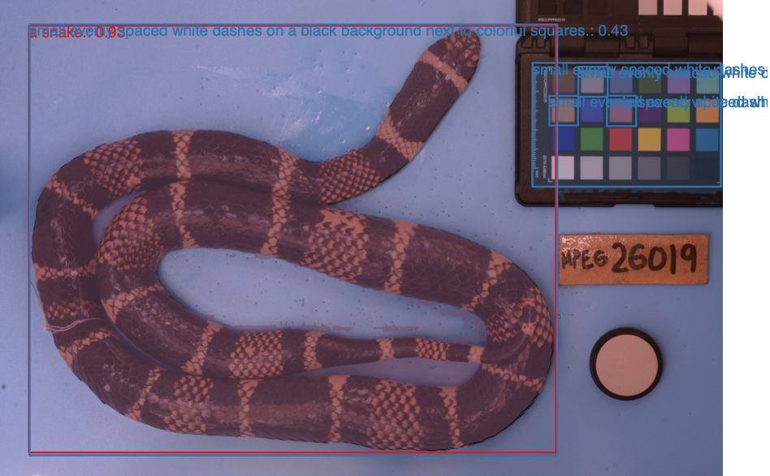

Example 6:

Text prompt: "an individual leaf."

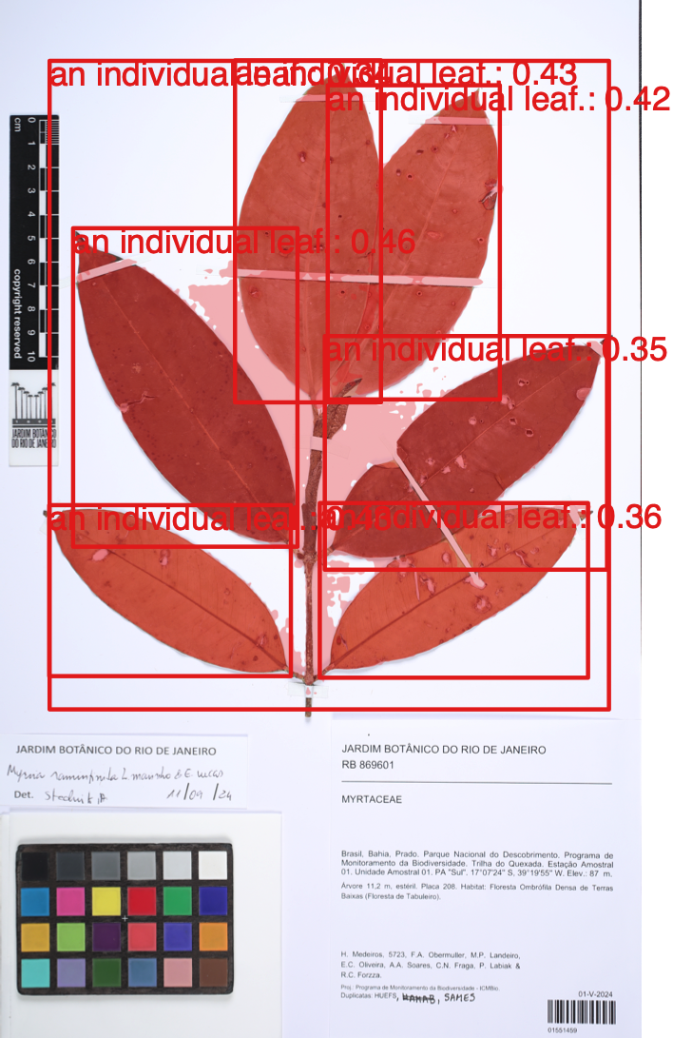

Example 7:

Text prompt: "an individual leaf.", "a paper with text on it in the bottom corner."

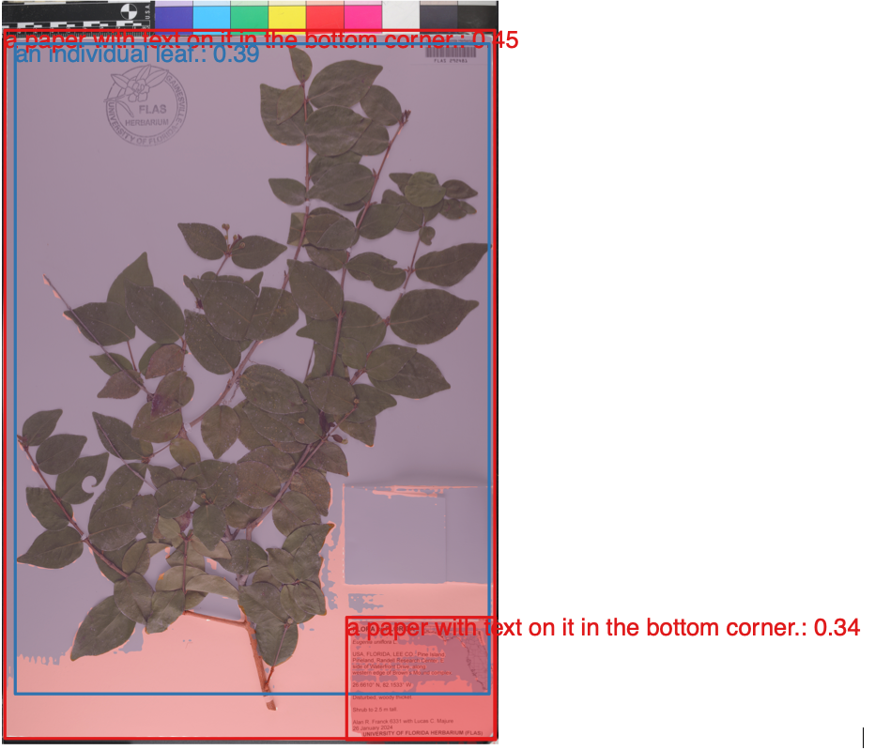

**CODE**

# library(SegmentR)

library(imager)

library(recolorize)

setwd("~/SegmentR/")

devtools::load_all()

##### EXAMPLE 1

results <- run_grounded_segmentation("~/segmentr-paper/extdata/images/other_images/HornedBream.jpg", labels = c("a fish.", "a fin."))

results <- get_segmentation_paths("~/segmentr-paper/extdata/images/other_images/HornedBream.jpg")

seg_res <- load_segmentation_results(results$image_path)

seg_tbl <- create_segmentation_table(seg_res)

seg_res <- remove_mask(seg_res, 2)

export_transparent_png(input = seg_res, output_path = "~/segmentr-paper/extdata/exported_segments/", remove_overlap = TRUE, crop = TRUE)

export_transparent_png(input = seg_res, prefix = "full_bream", output_path = "~/segmentr-paper/extdata/exported_segments/", remove_overlap = FALSE, crop = TRUE)

img <- readImage(results$image_path, resize = NULL, rotate = NULL)

pdf("~/segmentr-paper/figures/in-progress/example-1-original.pdf", width = 10, height = 7)

plotImageArray(img, main = "")

dev.off()

pdf("~/segmentr-paper/figures/in-progress/example-1-segmented.pdf", width = 10, height = 7)

plot_seg_results(seg_res, main = "")

dev.off()

##### EXAMPLE 2

init <- Sys.time()

run_grounded_segmentation("~/segmentr-paper/extdata/images", labels = c("an individual flower"))

results <- get_segmentation_paths("~/segmentr-paper/extdata/images")

seg_res <- load_segmentation_results(results$summary$source_directory)

for(i in 1:(length(seg_res)-1)){

focal <- seg_res[[i]]

export_transparent_png(input = focal,

output_path = "~/segmentr-paper/extdata/exported_segments/", remove_overlap = TRUE, crop = TRUE)

}

fin <- Sys.time()

fin - init

pdf(file = "~/segmentr-paper/figures/in-progress/example-2.pdf", width = 20, height = 15)

layout(matrix(1:20, nrow = 5), heights = c(1,1,1,1,0.25))

par(mar = c(1, 0, 1, 0))

# i = 1

for(i in 4:1){

img_path <- seg_res[[i]]$paths$image

img <- readImage(img_path, resize = NULL, rotate = NULL)

plotImageArray(img, main = "Original image", cex.main = 5)

img_tbl <- create_segmentation_table(seg_res[[i]])

plot_seg_results(seg_res[[i]], mask_alpha = 0.1, show_label = FALSE, show_score = FALSE, main = "Object detection")

flower_name <- sub("\\..*$", "",basename(img_path))

crop_dir <- dir("~/segmentr-paper/extdata/exported_segments/chosen_examples/", full.names = TRUE)

crop_path <- crop_dir[grep(flower_name, crop_dir)]

crop_img <- readImage(crop_path, resize = NULL, rotate = NULL)

plotImageArray(crop_img, main = "Segmentation and cropping")

init_fit <- recolorize(img = crop_img, plotting = FALSE)

recluster_results <- recluster(init_fit, cutoff = 45, plot_hclust = FALSE, plot_final = FALSE)

recolored_img <- constructImage(recluster_results$pixel_assignments, recluster_results$centers)

plotImageArray(recolored_img, main = "Recolored image")

plotColorPalette(recluster_results$centers)

}

dev.off()

##### EXAMPLE 3

results <- run_grounded_segmentation("~/segmentr-paper/extdata/images/other_images/DSC_4263.JPG", labels = c("a snake.", "a black square with colors in it."))

results <- get_segmentation_paths("~/segmentr-paper/extdata/images/other_images/DSC_4263.JPG")

seg_res <- load_segmentation_results(results$image_path)

seg_tbl <- create_segmentation_table(seg_res)

img <- readImage(results$image_path, resize = NULL, rotate = NULL)

pdf("~/segmentr-paper/figures/in-progress/example-3-original.pdf", width = 10, height = 7)

plotImageArray(img, main = "")

dev.off()

pdf("~/segmentr-paper/figures/in-progress/example-3-segmented.pdf", width = 10, height = 7)

plot_seg_results(seg_res, main = "")

dev.off()

##### EXAMPLE 4

results <- run_grounded_segmentation("~/segmentr-paper/extdata/images/other_images/DSC_8167.JPG", labels = c("a snake.", "a ruler."))

results <- get_segmentation_paths("~/segmentr-paper/extdata/images/other_images/DSC_8167.JPG")

seg_res <- load_segmentation_results(results$image_path)

seg_tbl <- create_segmentation_table(seg_res)

img <- readImage(results$image_path, resize = NULL, rotate = NULL)

pdf("~/segmentr-paper/figures/in-progress/example-4-original.pdf", width = 10, height = 7)

plotImageArray(img, main = "")

dev.off()

pdf("~/segmentr-paper/figures/in-progress/example-4-segmented.pdf", width = 10, height = 7)

plot_seg_results(seg_res, main = "")

dev.off()

##### EXAMPLE 5

results <- run_grounded_segmentation("~/segmentr-paper/extdata/images/other_images/DSC_8167.JPG", labels = c("a snake.", "small evenly spaced white dashes on a black background next to colorful squares."))

results <- get_segmentation_paths("~/segmentr-paper/extdata/images/other_images/DSC_8167.JPG")

seg_res <- load_segmentation_results(results$image_path)

seg_tbl <- create_segmentation_table(seg_res)

img <- readImage(results$image_path, resize = NULL, rotate = NULL)

pdf("~/segmentr-paper/figures/in-progress/example-5-original.pdf", width = 10, height = 7)

plotImageArray(img, main = "")

dev.off()

pdf("~/segmentr-paper/figures/in-progress/example-5-segmented.pdf", width = 10, height = 7)

plot_seg_results(seg_res, main = "")

dev.off()

##### EXAMPLE 6

results <- run_grounded_segmentation("~/segmentr-paper/extdata/images/other_images/myrcia.jpg", labels = c("an individual leaf."))

results <- get_segmentation_paths("~/segmentr-paper/extdata/images/other_images/myrcia.jpg")

seg_res <- load_segmentation_results(results$image_path)

seg_tbl <- create_segmentation_table(seg_res)

img <- readImage(results$image_path, resize = NULL, rotate = NULL)

pdf("~/segmentr-paper/figures/in-progress/example-6-original.pdf", width = 10, height = 7)

plotImageArray(img, main = "")

dev.off()

pdf("~/segmentr-paper/figures/in-progress/example-6-segmented.pdf", width = 10, height = 7)

plot_seg_results(seg_res, main = "")

dev.off()

##### EXAMPLE 7

results <- run_grounded_segmentation("~/segmentr-paper/extdata/images/other_images/euginia.jpeg", labels = c("an individual leaf.", "a paper with text on it in the bottom corner."))

results <- get_segmentation_paths("~/segmentr-paper/extdata/images/other_images/euginia.jpeg")

seg_res <- load_segmentation_results(results$image_path)

seg_tbl <- create_segmentation_table(seg_res)

img <- readImage(results$image_path, resize = NULL, rotate = NULL)

pdf("~/segmentr-paper/figures/in-progress/example-7-original.pdf", width = 10, height = 7)

plotImageArray(img, main = "")

dev.off()

pdf("~/segmentr-paper/figures/in-progress/example-7-segmented.pdf", width = 10, height = 7)

plot_seg_results(seg_res, main = "")

dev.off()